QN-3 EXCEL

OPEN THE OPEN OFFICE

NAME,AND SUBJECT ARE ADD THEN NO

TOTAL FORMULA IS =SUM(B2:F2)

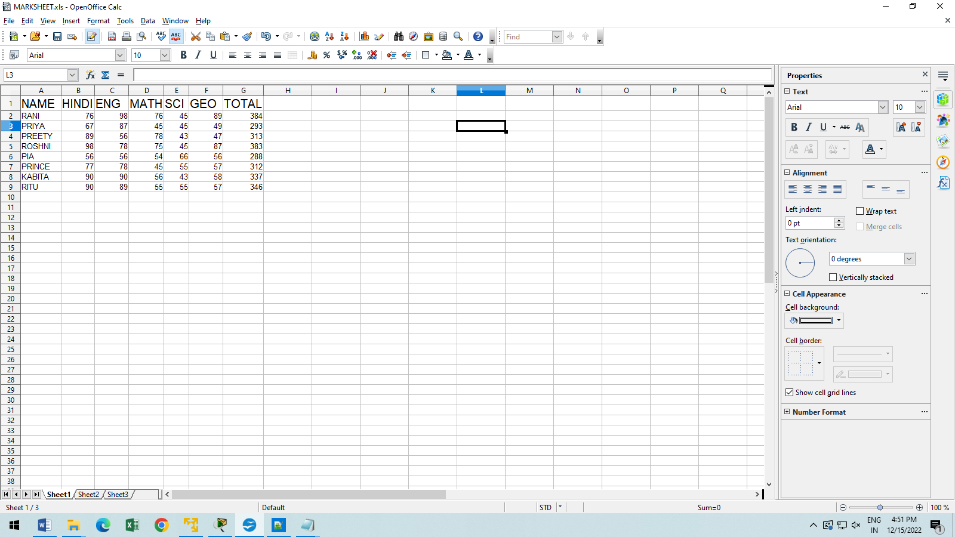

QN-2 FTP CISCO PACKET TRACER LOG IN

SELECT 2 PC AND 2 SERVER AND ONE SWITCH

1ST SERVER NAME IS DNS AND 2ND FTP

CONNECT TO THE STRAIGHT LINE CABLE

PC AND SERVER IP CONFIGRATION

FTP ON

THEN START THE SIMULATION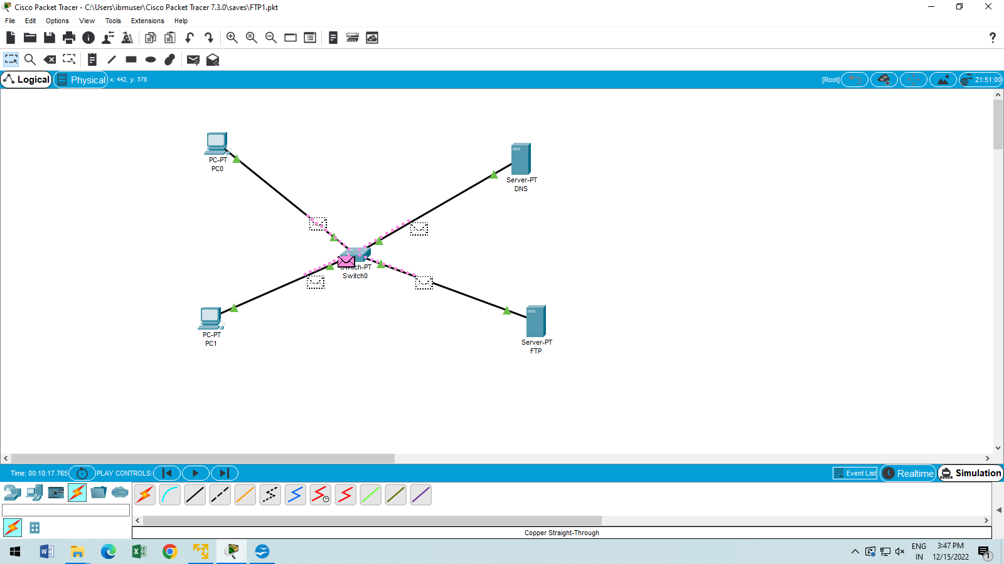QN-1 LINEX

STEP-1 OPEN THE VMWARE,AND UBANTU LOG IN

STEP-2 OPEN THE TERMINAL AND START EXECUTE THE LINEX COMMANDS

TOUCH

ECHO

MKDIR

CAT

HEAD

CP

MV

WC

FIND

TAIL

DIR

RM

RMDIR

CLEAR





